NAAN MUDHALVAN PROJECT
ST. TERESA ARTS AND SCIENCE COLLEGE FOR WOMEN ,MANGALAKUNTU-629178
(AFFILIATED TO ΜΑΝΟΝΜΑΝΙAM SUNDARANAR UNIVERSITY TIRUNELVELI)
KANYAKUMARI DISTRICT, TAMILNADU

This report is submitted to the Manonmaniam Sundaranar university, Tirunelveil. In partial fulfillment of the requirement for the degree of
BACHELOR OF SCIENCE IN COMPUTER SCIENCE
Topic: HTML Quick Styler
Submitted by
T. Haili Judiciya
A. Varshini
V. Sheenu
S. Rithusha Shalika
Under the Guidance of
MRS.T.D. JAIN SUBHA
(Asso.prof., Dept. of Computer Science)

DEPARTMENT OF COMPUTER SCIENCE

HTML Quick Styler
Project Description:
HTML Quick Stylar is a web-based tool that helps users quickly generate and style HTML webpages without writing complex CSS code. It allows users to choose layouts, colors, fonts, and styles easily through a simple interface. This tool is useful for beginners, designers, and developers who want to quickly create visually appealing webpages.
The platform provides predefined templates and customization options so users can generate modern website designs in a few clicks.
Scenarios:
Scenario 1: Portfolio Website Generation
A freelance designer wants to create a personal portfolio website to showcase their work. Using HTML Quick Stylar, they select a portfolio template, customize colors, add project images, and adjust fonts. Within minutes, the designer generates a professional-looking portfolio webpage without writing much code.
Scenario 2: SaaS Landing Page
A startup launching a SaaS product needs a landing page to promote their service. With HTML Quick Stylar, the team selects a landing page layout, adds sections like features, pricing, and testimonials, and applies branding colors. The tool quickly generates a responsive landing page ready for deployment.
Scenario 3: Corporate Website
A small company wants a simple corporate website to display company information, services, and contact details. Using HTML Quick Stylar, the company chooses a corporate template, customizes the header, navigation menu, and footer, and creates a professional business website easily.

Scenario 4: Custom Color Palette Exploration
A UI/UX designer wants to experiment with different color combinations for a website design. HTML Quick Stylar allows the designer to test various color palettes, preview them in real-time on webpage elements, and select the best combination for their project.
Architecture Overview:
The HTML Quick Stylar system follows a simple client-side web application architecture.
User Interface Layer:
Users interact with the system through a web browser where they select styles, templates, colors, and layouts.
Processing Layer:
JavaScript processes the user inputs such as color selection, font style, and layout preferences.
Generation Layer:
The system dynamically generates styled HTML and CSS code based on the user's selections.
Output Layer:
The final styled webpage is displayed instantly and users can download or copy the generated HTML/CSS code.
This architecture makes the system lightweight and easy to use.
Core Technologies:
The main technologies used in the project include:
- HTML5 – Structure of the webpage
- CSS3 – Styling and layout design
- JavaScript – Dynamic functionality and style generation
- Bootstrap (optional) – Responsive design templates
- Web Browser – To run and test the application

Pre-Requisites:
Before developing or using HTML Quick Stylar, the following should be available:
- Basic computer system
- Internet browser (Chrome, Edge, Firefox)
- Code editor (VS Code / Notepad++)
- Basic understanding of web development
Software Requirements:
The software required for the project are:
- Operating System: Windows / Linux / macOS
- Code Editor: Visual Studio Code / Sublime Text / Notepad++
- Web Browser: Google Chrome / Mozilla Firefox / Microsoft Edge
- Optional Tools: Bootstrap framework, Git for version control
Knowledge Prerequisites:
To develop this project, the user should know:
- Basics of HTML structure
- CSS styling and layouts
- JavaScript fundamentals
- Understanding of web page design concepts
- Basic knowledge of responsive web design
Hardware Requirements:
Minimum hardware requirements include:
- Processor: Intel i3 or equivalent
- RAM: 4 GB or higher
- Storage: 500 MB free space
- Display: Standard monitor
- Input Devices: Keyboard and Mouse

Project workflow:
The workflow of the HTML Quick Stylar project explains how the system is developed and executed from setup to output generation.
Phase 1: Environment Setup & Model Configuration:
To run the project successfully, the development environment must be properly configured. This involves setting up the platform, installing libraries, and connecting the AI model.
Activity 1.1: Set Up Google Colab Environment:
Google Colab is used to run the project because it provides a cloud-based Python environment.
Steps:
- Open Google Colab in a web browser.
- Create a new notebook.
- Install required Python libraries using pip.
- Enable GPU or CPU runtime if necessary.
- Upload or write the project code in the notebook.
Activity 1.2: Configure IBM Granite Model:
IBM Granite is a generative AI model used to generate HTML and styling suggestions.
Steps to configure the model:
- Import required libraries.
- Load the IBM Granite model from the repository.
- Initialize the model in the environment.
- Connect the model with the input prompt system.
Activity 1.3: Install and Configure Gradio:
Gradio is used to create a simple web interface for interacting with the AI model.

Steps:
- Install Gradio using pip.
- Create input fields for user requirements.
- Connect the input to the AI model.
- Display the generated output on the interface.

Phase 2: Core Application Development:
Activity 2.1: Build Color Palette Generator:
The color palette generator is a feature that automatically creates a set of harmonious colors based on a base color selected by the user. It helps designers and developers quickly choose matching colors for backgrounds, text, buttons, and other UI elements. The generator may use color theory rules such as complementary, analogous, or triadic color schemes to produce visually appealing palettes.
Activity 2.2: Implement HTML Page Builder:
The HTML page builder allows users to create web pages visually without manually writing HTML code. It provides drag-and-drop functionality where users can add elements like headers, text blocks, images, buttons, and forms. The builder then converts these elements into structured HTML code in the background, making website creation easier for beginners.
Activity2.3: Develop CSS Generation Engine:
The CSS generation engine automatically produces CSS styles based on the user’s design choices. When users adjust colors, fonts, spacing, or layout in the interface, the engine generates the corresponding CSS rules. This ensures that the visual design is correctly applied to the web page while maintaining organized and reusable style code.
Activity2.4: Build Section Templates:
Section templates are pre-designed layouts that users can insert into their web pages. Examples include hero sections, navigation bars, feature sections, testimonials, and footers. These templates save time and help maintain design consistency. Users can customize the content, colors, and images within each template according to their needs.

Phase 3: Gradio Interface Development:

Gradio Interface Development focuses on creating a user-friendly interface that allows users to interact with the application easily. It enables users to generate HTML code dynamically and preview the results instantly.
Activity 3.1: Interactive HTML Generation & Preview Interface:
The interactive preview interface allows users to see the generated webpage instantly without copying the code into another editor.
Features
- Real-time HTML generation
- Live webpage preview
- Custom style selection
- Easy interface for beginners
Phase 4:Google Colab Deployment:
Integrate all components and perform comprehensive testing
Activity 4.1: End-to-End Integration:
- Connect all interface components
- Test data flow between tabs
- Validate generation pipeline
- Test error handling
- in the future.
Phase 5 :Deployment & Documentation
Functionality Testing
Functionality testing is performed to ensure that all features of the application work as expected. Each module is tested individually and as part of the complete system.

Technical Architecture:

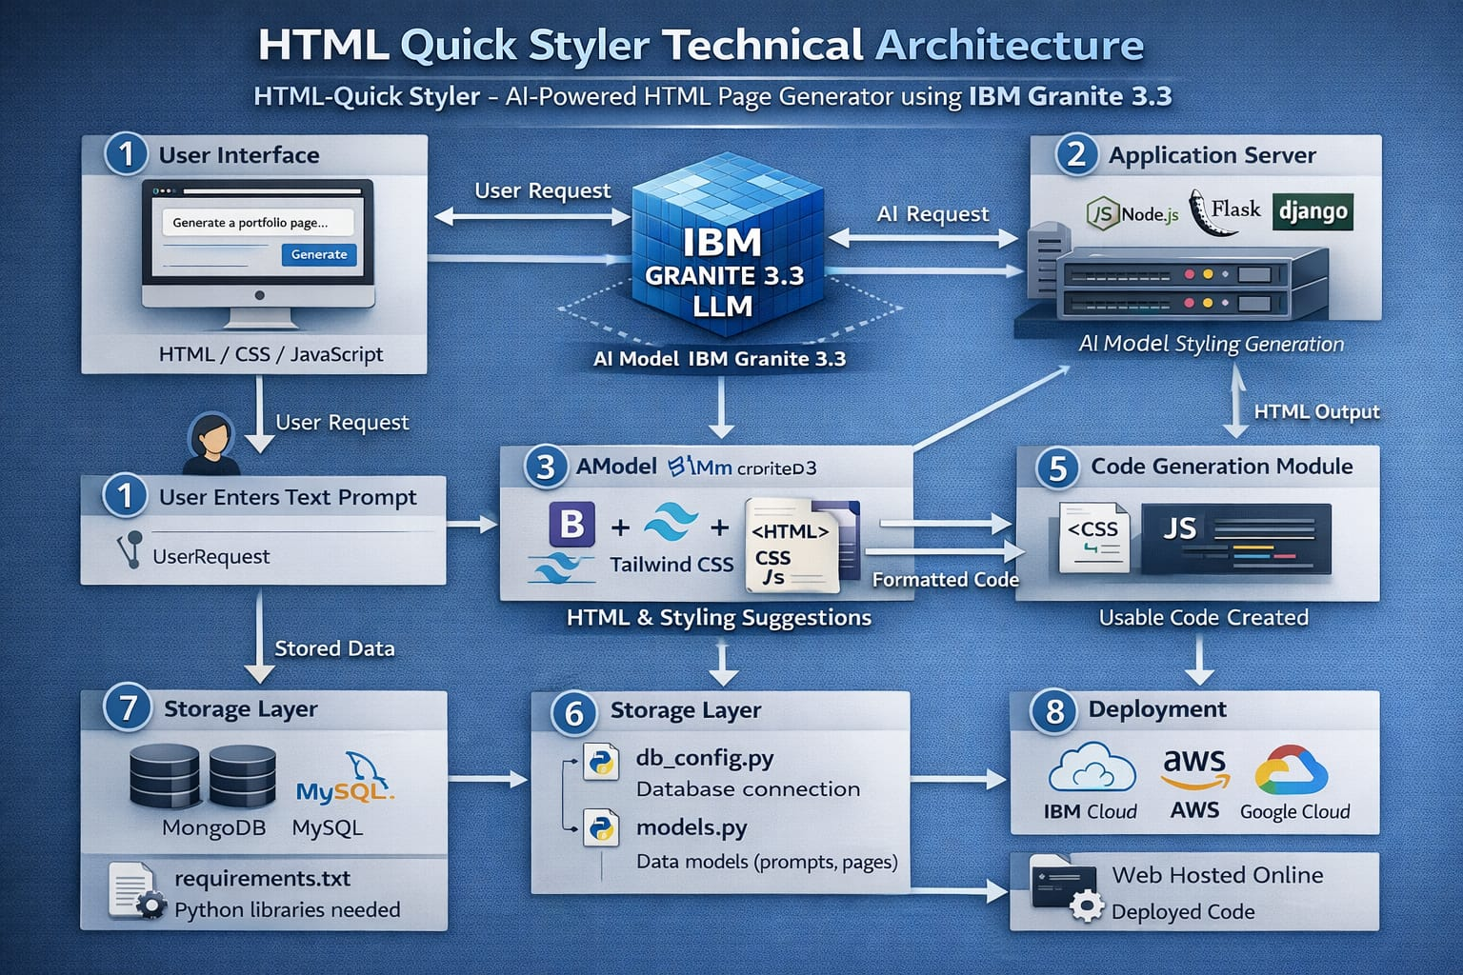

Project Structure:

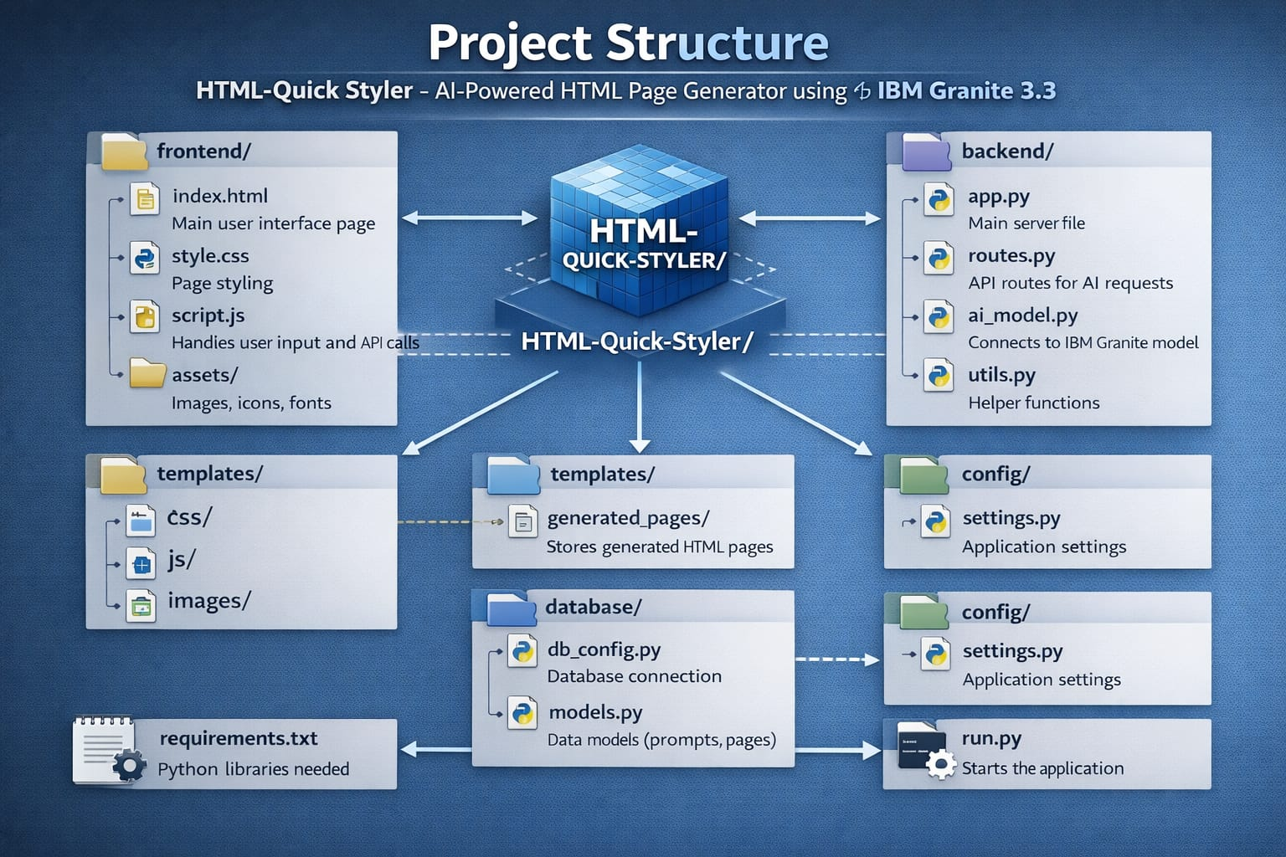

MILESTONE 1: Environment Setup & Model Configuration
Establish Google Cobal environment and configuration Granite models

Activity 1.1: Install Dependencies & Setup Environment
To set up a Python programming environment and manage dependencies, follow these steps to create an isolated workspace and install necessary libraries.
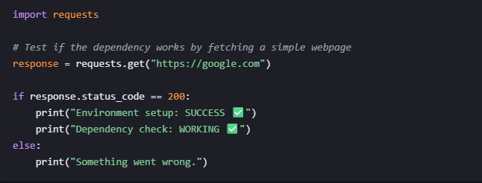

Activity 1.2: Configure IBM Granite Model
Configuring an IBM Granite model depends on whether you are running it locally for development or deploying it for enterprise use.
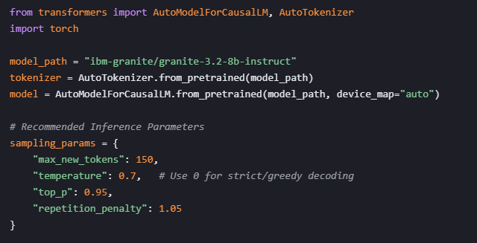

MILESTONE 2: Core Application Development

Activity 2.1: Color palette Generator Implementation
To implement this, we define a dictionary of predefined schemes in the backend and use a selection logic to cycle through them. This setup replaces random generation with curated arrays of hex codes.

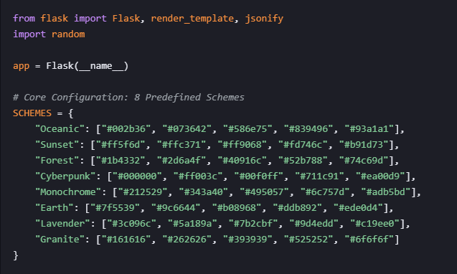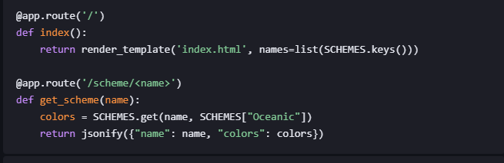

Activity 2.2: HTML Page Builder Implementation
The HTML Page Builder class is used to generate styled HTML pages from user descriptions.
Functions of HTML Page Builder
- Extract sections from user descriptions
- Detect keywords such as hero, features, about, portfolio, testimonials, pricing, contact, and footer
- Generate SEO meta tagsCreate HTML for each section using template

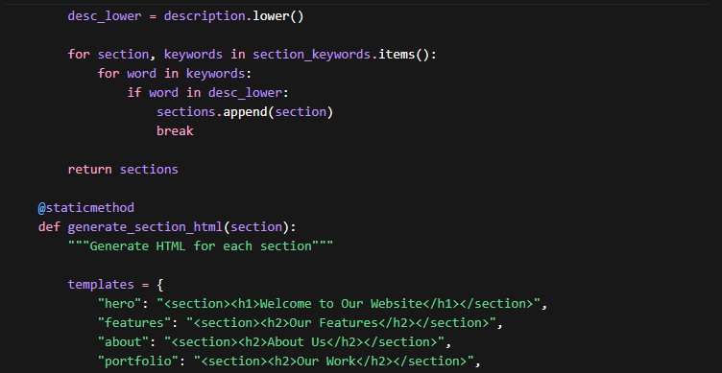

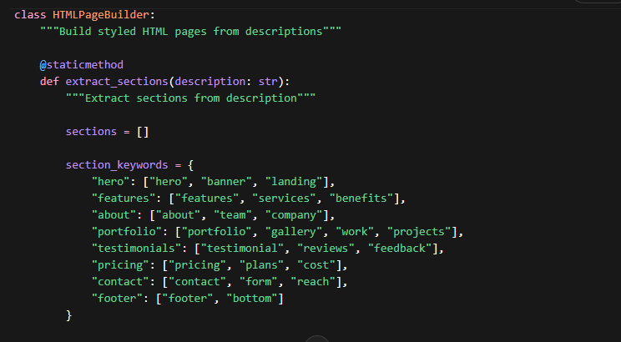

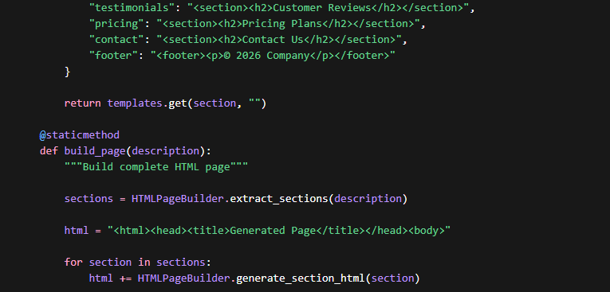

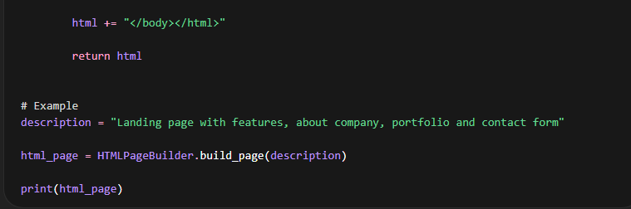

Activity 2.3 CSS Generation Engine
The CSS Generation Engine automatically creates styles for different sections of a generated HTML page.
It ensures the page has a clean layout, responsive design, and professional appearance.
Functions of CSS Generation Engine
- Generate global CSS styles for the page
- Apply styles for sections like hero, features, about, portfolio, contact, and footer
- Create responsive layouts using Flexbox/Grid
- Maintain consistent fonts, spacing, and colors

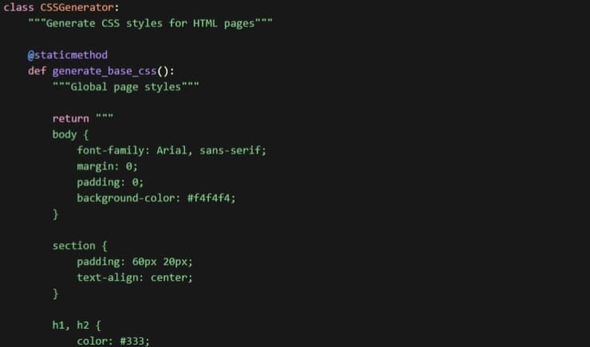

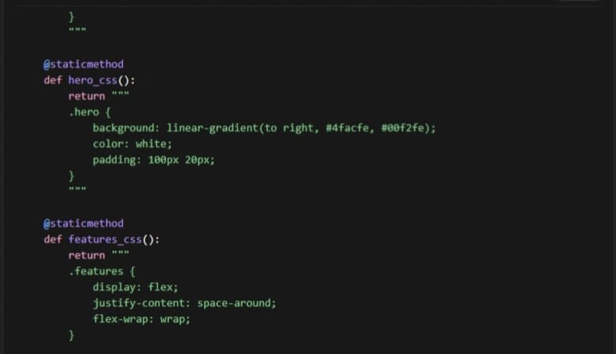
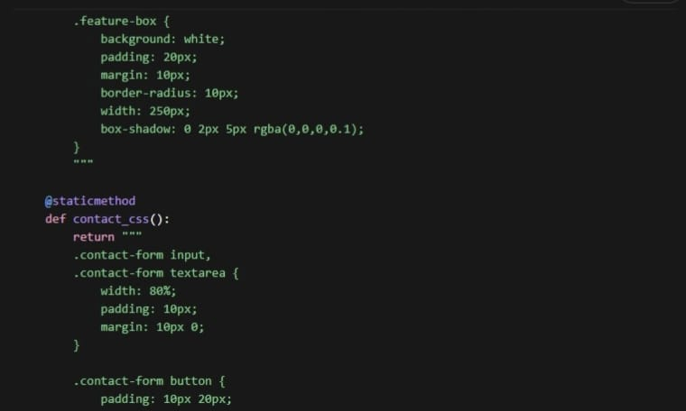
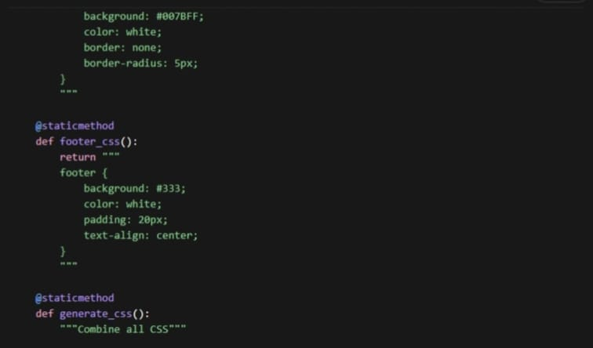
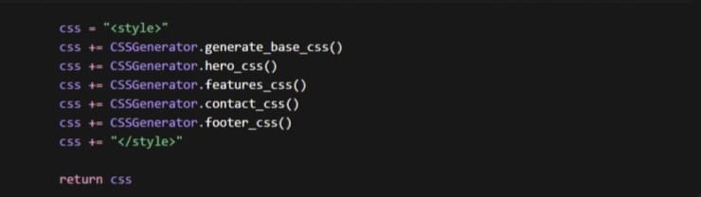

MILESTONE 3: Gradio Interface Development
Activity 3.1 Main Interface with Multiple Tabs
The Gradio interface includes 5 tabs

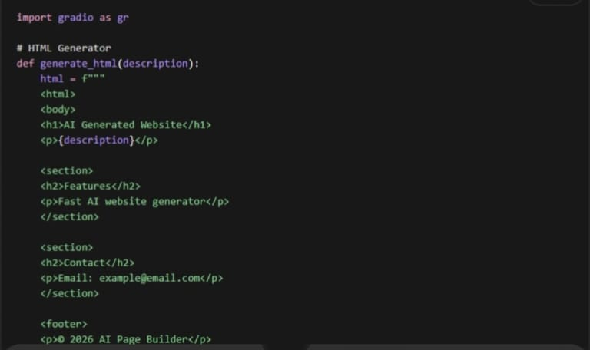
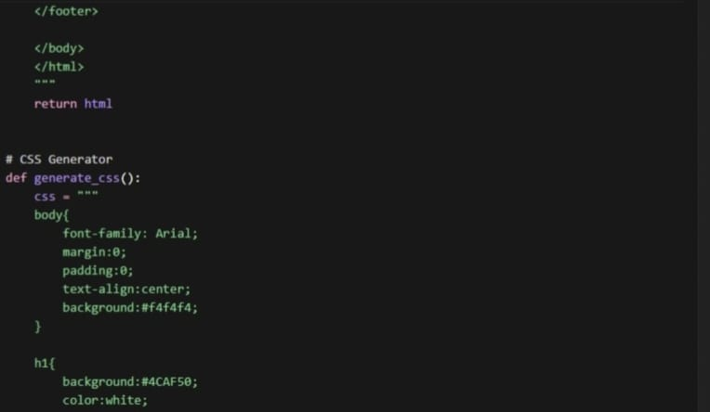

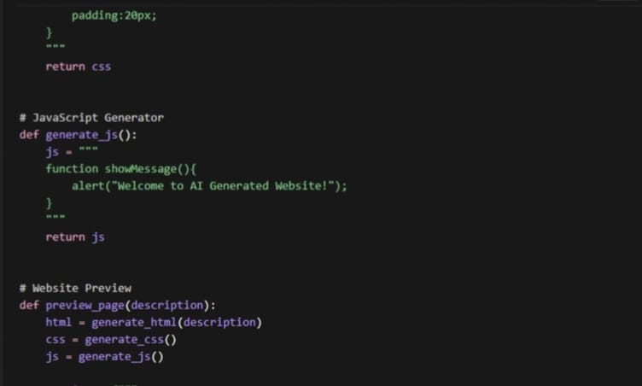
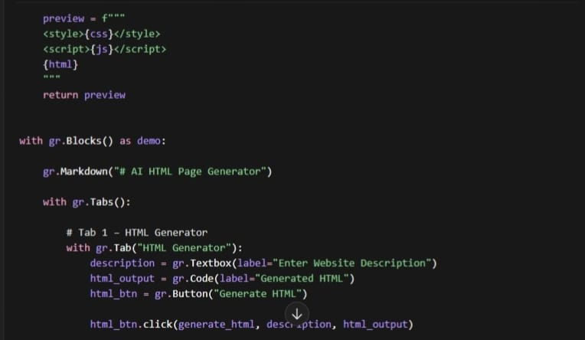
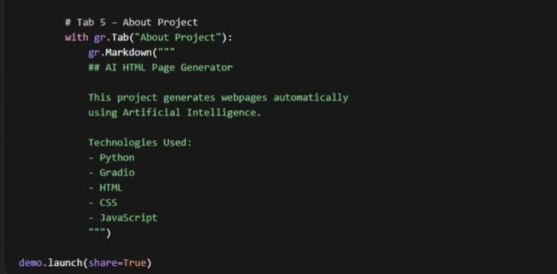

MILESTONE 4: Deployment

Activity 4.1 Google Colab Deployment
Launching an application in Google Colab means running your program in a cloud-based Python environment so that it can be accessed through a web browser. It is widely used for machine learning, AI projects, and web interface testing.

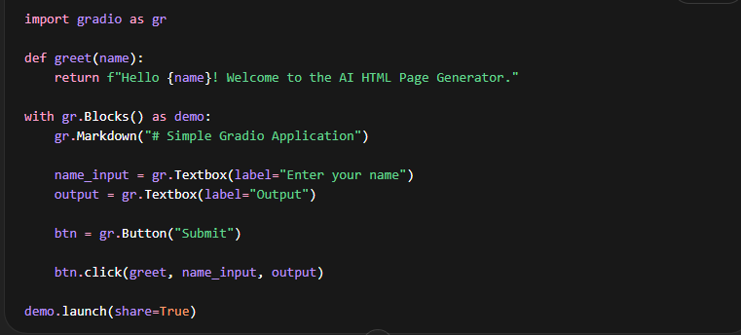
MILESTONE 5: Testing & Validation
Activity 5.1: Functional Testing
Inputs
- To check whether the system accepts user descriptions correctly
- To verify that the HTML page is generated based on the input
- To ensure the application responds without errors
Expected output 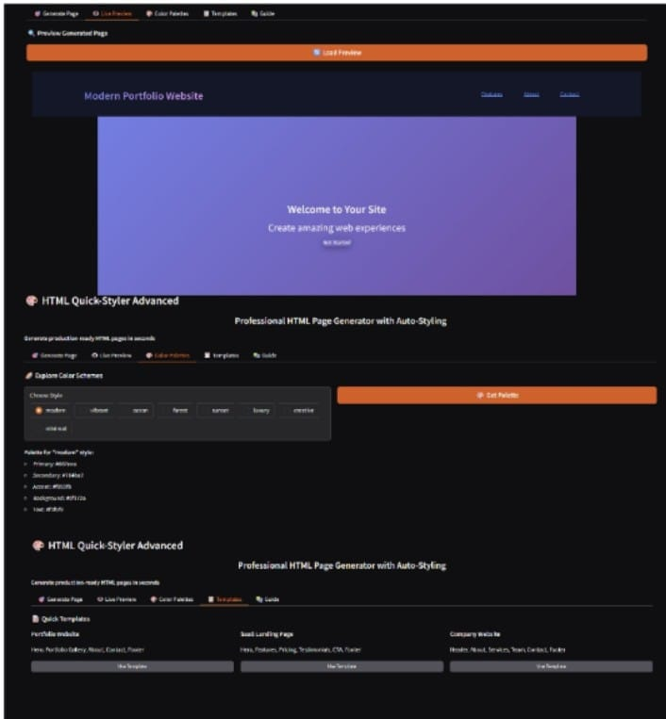

Conclusion:

The AI HTML Page Generator project successfully demonstrates how artificial intelligence can be used to automatically create web pages from user descriptions. The system allows users to enter a simple description of a website, and it generates the HTML structure, CSS styling, and webpage preview through an interactive interface.
The project uses Gradio to develop an easy-to-use interface and Google Colab to run and deploy the application in a cloud environment. This makes the system simple to access and test without requiring complex software installation.
Through different modules such as HTML generation, CSS generation, JavaScript generation, and website preview, the application provides a complete workflow for building basic web pages automatically. Functional testing confirms that each component works correctly and produces the expected output.
Overall, the project shows how AI tools can simplify the web development process, save time, and help beginners quickly generate website layouts from text descriptions. It also demonstrates the integration of AI concepts with modern web technologies in a practical application.

